Understanding MAP-REDUCE

1) Download attachment in **STAGING_AREA**



2) Pull it in **LABS_HOME/demos**



Lab Manual steps

Putting file into hdfs

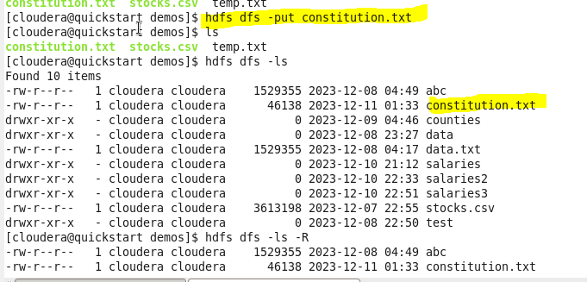

Running wordcount jar



Error

Find the file



To find soft link (Blue color)



..

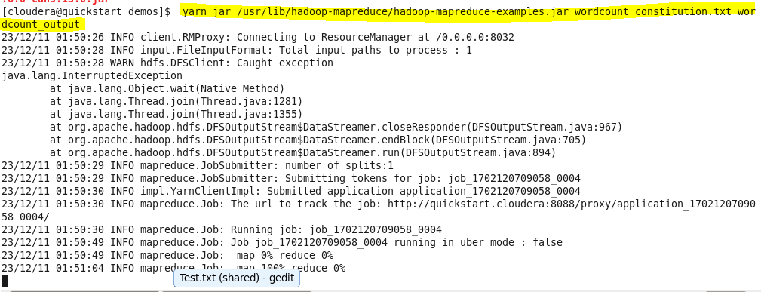

Delete wordcount file and then again yarn

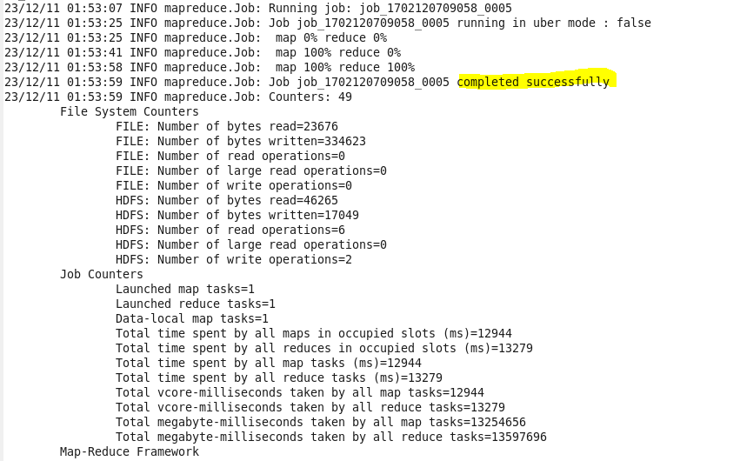

…

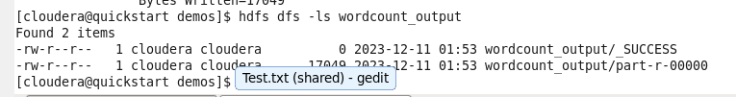

…



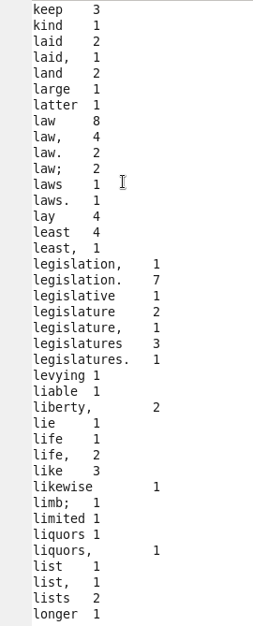

Cccc

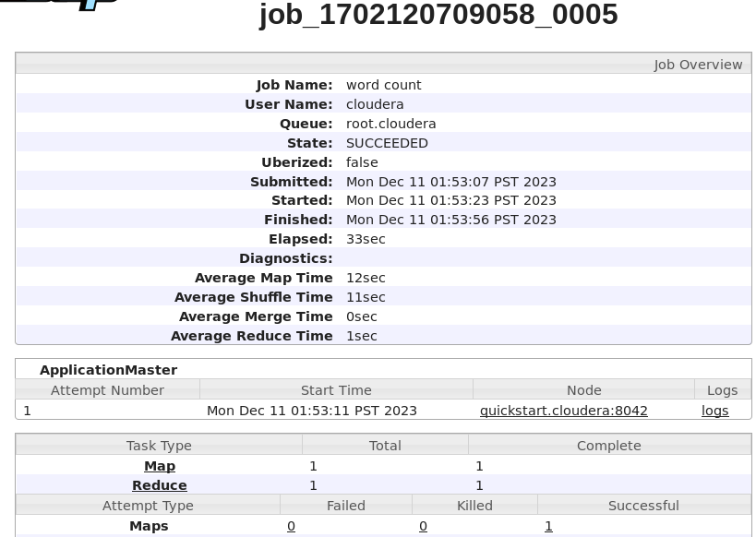

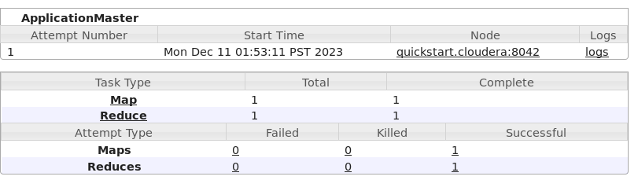

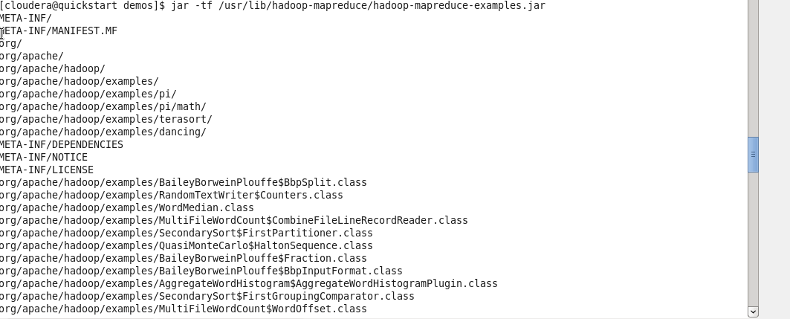

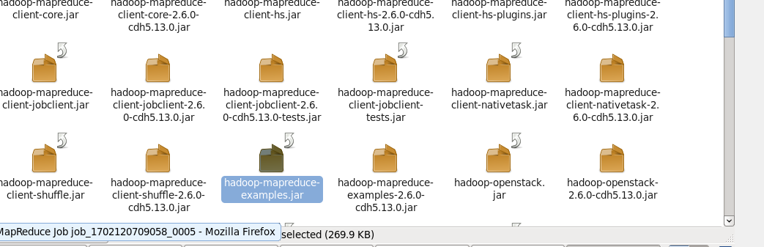

…

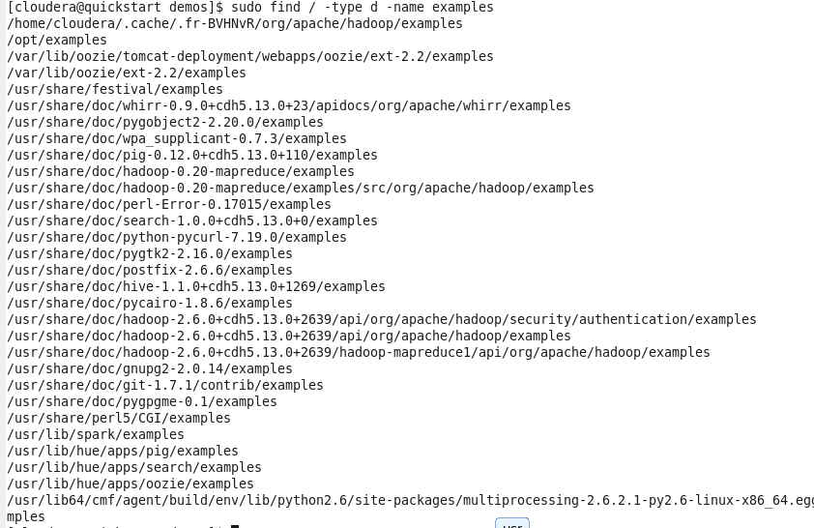

Assignment

1.

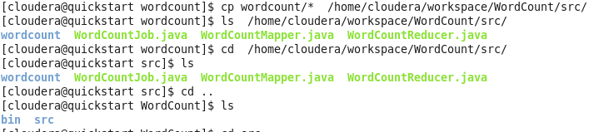

…

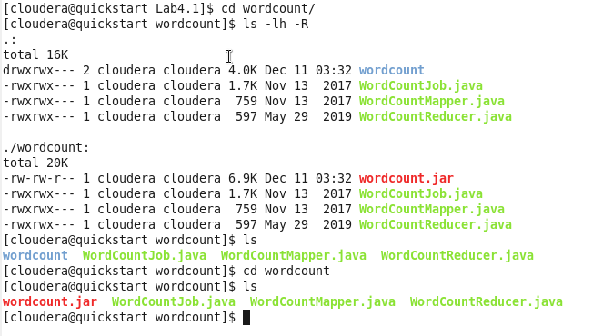

…

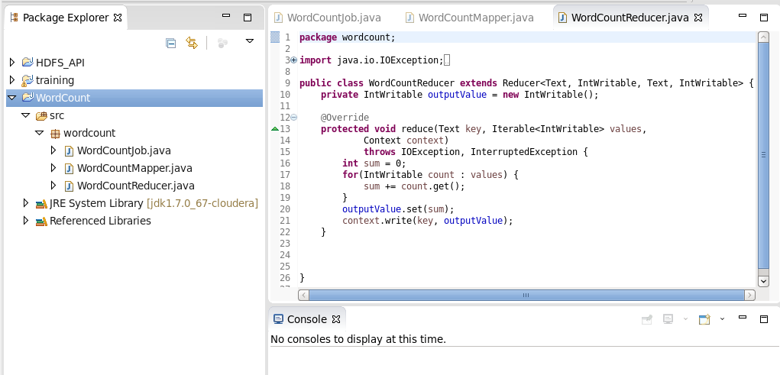

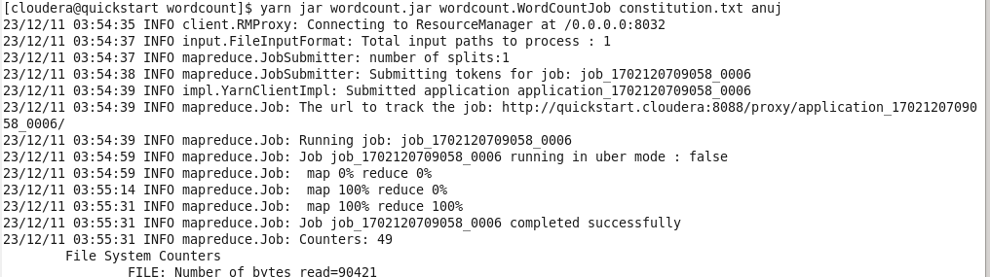

…

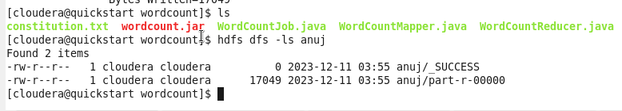

…



Here wordcount.jar is jarfile name, wordcount is package and WordCountJob is class name and constitution.txt ->input of text file name and anuj -> we put output here

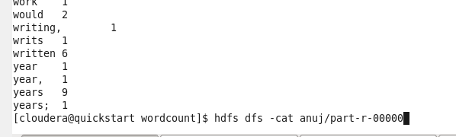

Full output with map reduce like key value with words counts is shown.

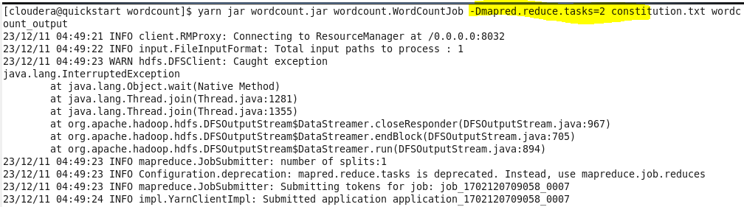

Setting the configuration here, -Dmapred.reduce.tasks=2, we can increase as per our requirement and by default value is 1

